**Normal Distribution Vs Uniform Distribution**

**Contents**  [hide](https://thatascience.com/learn-numpy/normal-vs-uniform/)

[1. Normal Distribution Vs Uniform Distribution](https://thatascience.com/learn-numpy/normal-vs-uniform/#Normal_Distribution_Vs_Uniform_Distribution)

[1.1. Code to generate and plot Normal Distribution Vs Uniform distribution](https://thatascience.com/learn-numpy/normal-vs-uniform/#Code_to_generate_and_plot_Normal_Distribution_Vs_Uniform_distribution)

[1.2. To Conclude - That's Normal Distribution Vs Uniform Distribution](https://thatascience.com/learn-numpy/normal-vs-uniform/#To_Conclude_-_Thats_Normal_Distribution_Vs_Uniform_Distribution)

[1.2.1. Related Resources:](https://thatascience.com/learn-numpy/normal-vs-uniform/#Related_Resources)

Normal Distribution is a probability distribution where probability of x is highest at centre and lowest in the ends whereas in Uniform Distribution probability of x is constant.

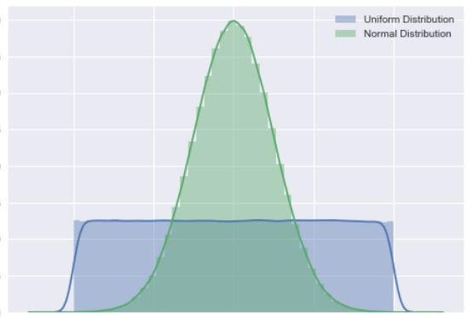

**Normal Distribution** is a probability distribution which peaks out in the middle and gradually decreases towards both ends of axis.  It is also known as gaussian distribution and bell curve because of its bell like shape. Formula for normal probability distribution is as follows, where  μ is mean and σ2 is variance.

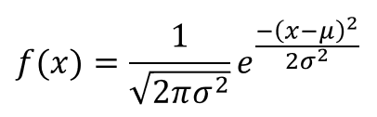

**Uniform Distribution** is a probability distribution where probability of x is constant. That is to say, all points in range are equally likely to occur consequently it looks like a rectangle. Formula for Uniform probability distribution is f(x) = 1/(b-a), where range of distribution is [a, b].

Below we have plotted 1 million normal random numbers and  uniform random numbers. .

Author: [**Ankit**](https://thatascience.com/about)**(thatascience)**

**Code to generate and plot Normal Distribution Vs Uniform distribution**

*# Imports*

**import** **numpy** **as** **np**

**import** **matplotlib.pyplot** **as** **plt**

**import** **seaborn** **as** **sns**

sns.set()

**import** **warnings**

warnings.simplefilter("ignore", **UserWarning**)

*# Let's create an array of random numbers from uniform distribution*

uniform = np.random.uniform(-4,4,1000000)

*# Let's create an array of random numbers from normal distribution*

normal = np.random.randn(1000000)

*# Let's plot them*

ax = sns.distplot(uniform, label='Uniform Distribution')

bx = sns.distplot(normal, label= 'Normal Distribution')

legend = plt.legend()

plt.show()

**To Conclude - That's Normal Distribution Vs Uniform Distribution**

That’s all for this mini tutorial. To sum it up, we learned the difference between normal distribution and uniform distribution. Further, we learned how to generate and plot the distributions using numpy and seaborn respectively.

Hope it was easy, cool and simple to follow. Now it’s on you.

### **Normal Distribution Problems and Solutions**

**Question 1: Calculate the probability density function of normal distribution using the following data. x = 3, μ = 4 and σ = 2.**

Solution: Given, variable, x = 3

Mean = 4 and

Standard deviation = 2

By the formula of the probability density of normal distribution, we can write;

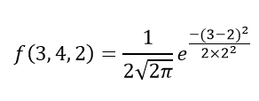

Hence, f(3,4,2) = 1.106.

**Question 2: If the value of random variable is 2, mean is 5 and the standard deviation is 4, then find the probability density function of the gaussian distribution.**

Solution: Given,

Variable, x = 2

Mean = 5 and

Standard deviation = 4

By the formula of the probability density of normal distribution, we can write;

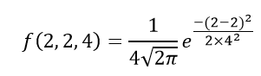

f(2,2,4) = 1/(4√2π) e0

f(2,2,4) = 0.0997

There are two main parameters of normal distribution in statistics namely mean and standard deviation. The location and scale parameters of the given normal distribution can be estimated using these two parameters. 

### **Normal Distribution Properties**

Some of the important properties of the normal distribution are listed below:

* In a normal distribution, the mean, median and mode are equal.(i.e., Mean = Median= Mode).
* The total area under the curve should be equal to 1.
* The normally distributed curve should be symmetric at the centre.
* There should be exactly half of the values are to the right of the centre and exactly half of the values are to the left of the centre.
* The normal distribution should be defined by the mean and standard deviation.
* The normal distribution curve must have only one peak. (i.e., Unimodal)
* The curve approaches the x-axis, but it never touches, and it extends farther away from the mean.

### **Applications**

The normal distributions are closely associated with many things such as:

* Marks scored on the test
* Heights of different persons
* Size of objects produced by the machine
* Blood pressure and so on.

## Frequently Asked Questions on Normal Distribution – FAQs

### **What is a normal distribution in statistics?**

A probability function that specifies how the values of a variable are distributed is called the normal distribution. It is symmetric since most of the observations assemble around the central peak of the curve. The probabilities for values of the distribution are distant from the mean narrow off evenly in both directions.

### **What does normal distribution mean?**

In statistics (and in probability theory), the Normal Distribution, also called the Gaussian Distribution, is the most important continuous probability distribution. Sometimes it is also called a bell curve.

### **What is a normal distribution used for?**

A normal distribution is significant in statistics and is often used in the natural sciences and social arts to describe real-valued random variables whose distributions are unknown.

### **What are the characteristics of a normal distribution?**

The essential characteristics of a normal distribution are:  
It is symmetric, unimodal (i.e., one mode), and asymptotic.  
The values of mean, median, and mode are all equal.  
A normal distribution is quite symmetrical about its center. That means the left side of the center of the peak is a mirror image of the right side. There is also only one peak (i.e., one mode) in a normal distribution.

### **How do you know if data is normally distributed?**

A histogram presents a useful graphical representation of the given data. When a histogram of distribution is superimposed with its normal curve, then the distribution is known as the normal distribution.

### **How do you use a normal distribution table?**

As we know, the label for rows contains the integer part and the first decimal place of z. In contrast, the title for columns comprises the second decimal place of z. The values within the table are the probabilities corresponding to the table type. Hence, to get the value of 0.56 from the z-table, identify the probability value corresponding to the 0.5 row and 0.06 column (=0.2123).

# Normal Distribution vs. Standard Normal Distribution: The Difference

The [normal distribution](https://www.statology.org/the-normal-distribution/) is the most commonly used probability distribution in statistics.

It has the following properties:

* [Symmetrical](https://www.statology.org/symmetric-distribution/)
* Bell-shaped
* Mean and median are equal; both located at the center of the distribution

The mean of the normal distribution determines its location and the standard deviation determines its spread.

For example, the following plot shows three normal distributions with different means and standard deviations:

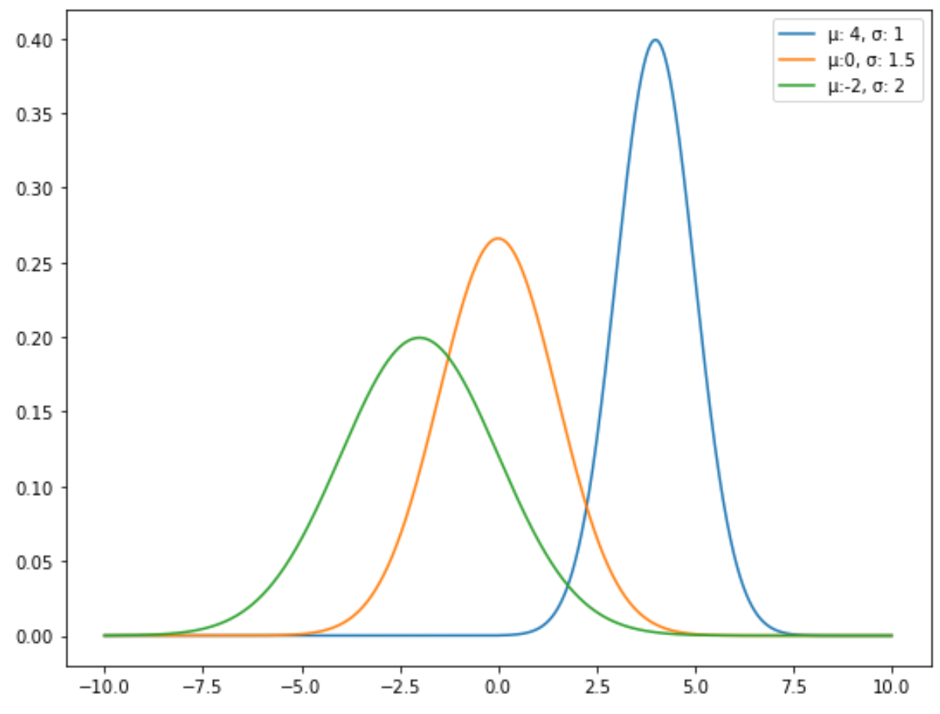

**The standard normal distribution is a specific type of normal distribution where the mean is equal to 0 and the standard deviation is equal to 1.**

The following plot shows a standard normal distribution:

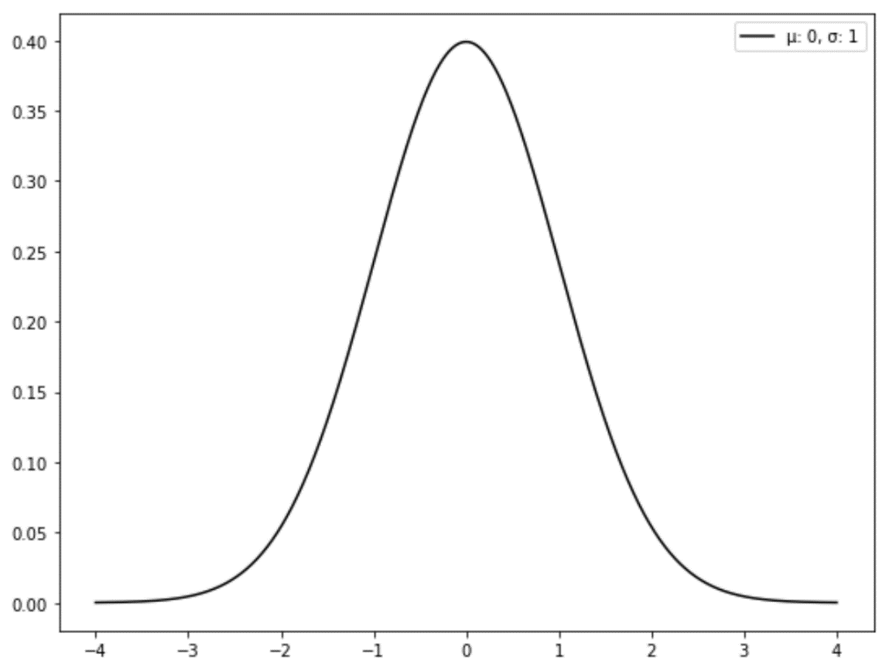

### **How to Convert a Normal Distribution to Standard Normal Distribution**

Any normal distribution can be converted into a standard normal distribution by converting the data values into z-scores, using the following formula:

**z = (x – μ) / σ**

where:

* **x:** Individual data value
* **μ:** Mean of the distribution
* **σ:** Standard deviation of the distribution

For example, suppose we have the following dataset with a mean of 6 and a standard deviation of 2.152:

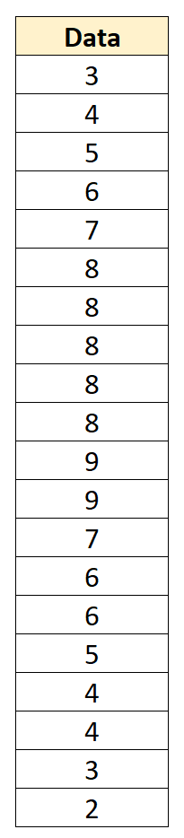

We can convert each individual data value into a z-score by subtracting 6 from each value and dividing by 2.152:

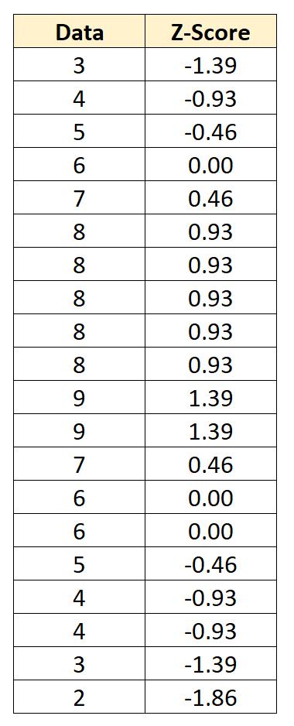

The **z-score** tells us how many standard deviations each data point lies from the mean. For example, the first data value of “3” lies 1.39 standard deviations below the mean.

The mean of this distribution of z-scores has a mean of zero and a standard deviation of one.

### **How to Use the Standard Normal Distribution**

A standard normal distribution has the following properties:

* About 68% of data falls within one standard deviation of the mean
* About 95% of data falls within two standard deviations of the mean
* About 99.7% of data falls within three standard deviations of the mean

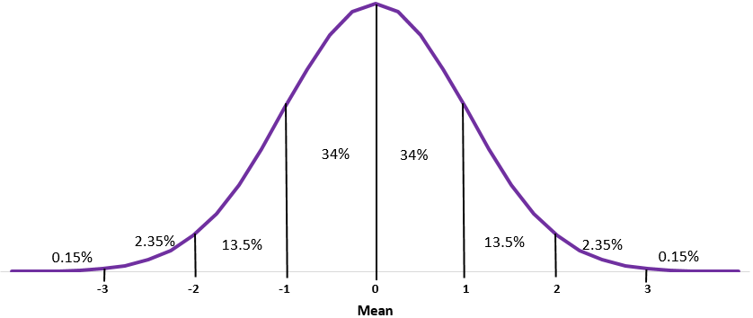

This is known as the **Empirical Rule** and is used to understand the distribution of values in a dataset.

For example, suppose the height of plants in a certain garden are normally distributed with a mean of 47.4 inches and a standard deviation of 2.4 inches.

According to the Empirical Rule, what percentage of plants are less than 54.6 inches tall?

The Empirical Rule states that for a given dataset with a normal distribution, 99.7% of data values fall within three standard deviations of the mean. This means that 49.85% of values fall between the mean and three standard deviations above the mean.